# Chapter 3

# Study Site and Data

**3.1 Petermann glacier**

Peterman glacier is one of the rapidly changing outlet glaciers in Northern Greenland that drains more than 4% of the total ice sheet. The glacier is situated around 81°N and 61°W and flows from south-east to north-west. The 90 km long fjord has deepest bed upto 1100m below the sea level. The ice tongue thins from nearly 600m thickness at the fjord front to around 100m at glacier front [Munchow] with ice thinning caused due to melting of underside ice by warm ocean water.[Rignot ,Steffen].

Petermann glacier has the second-longest floating ice shelf in Greenland with a permanent floating ice tongue [24,25], and flows with an average velocity of just over 1 km per annum [22].

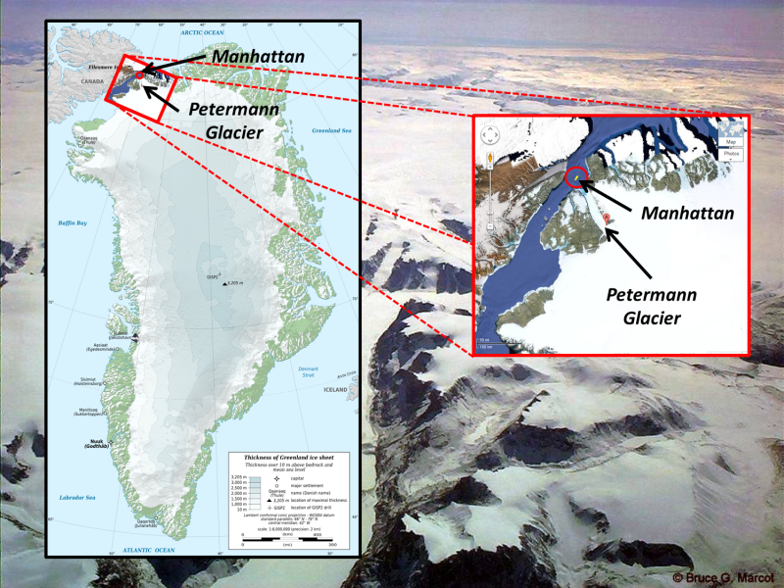

Two huge glacier calving events have occurred at Petermann Glacier over the past 5 years, one in 2010 (270 km2) and another in 2012 (130 km2) [22, 23]. The findings of Nick et al. (2012) and Grant 2013, show that the subglacial melting plays a critical role in the dynamics of Petermann Glacier, and understanding it can help predict future calving events.

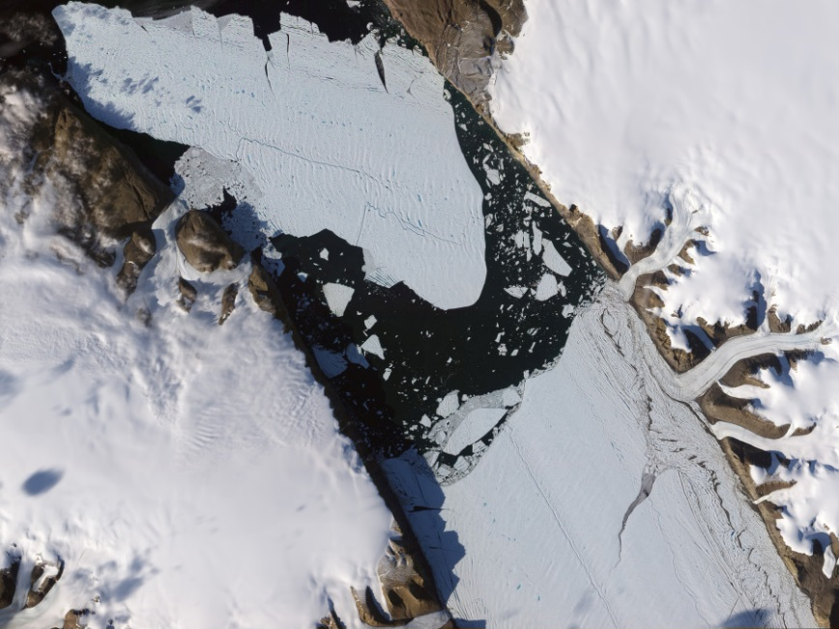

Fig. 1 Petermann glacier

**3.2 Jacobshavn glacier**

Jacobshavn glacier is in South West Greenland, the fastest moving glacier on earth which has very high ice calving rate. It now flows approximately at 1250myr-1 and drains nearly 7% of the total ice sheet [Bindschadler,1984] through 50 km long fjord to a bay. It forms at the confluence of two ice streams, a short slow one from the north and a long fast one from the east [Fastook]. Much of the floating tongue of jacobshavn isbrae has collapsed resulting into the accelerating of the glacier. This may be due to warming of the ocean water causing sub ice shelf melting or the subglacial drainage system in the catchment area.

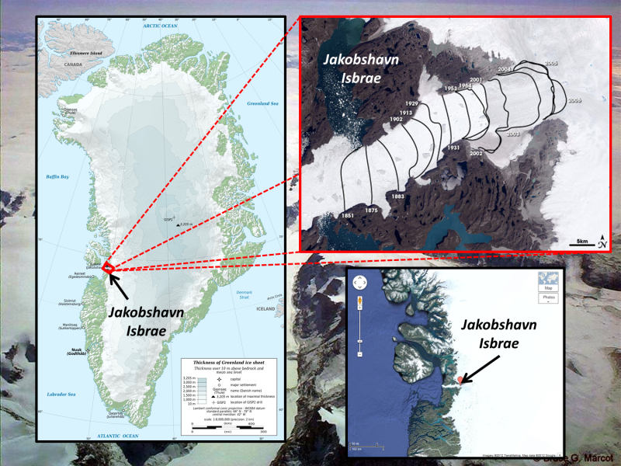

Fig. 2 Jacobshavn glacier

The glacier’s high flow acceleration and mass loss in addition to calving fromt retreat shown in figure 3 has become major concerns for the stability of the glacier. A recent large calving of approximately 7 km² took place on February 15, 2015. Understanding the ice dynamics of this glacier is thus very important.

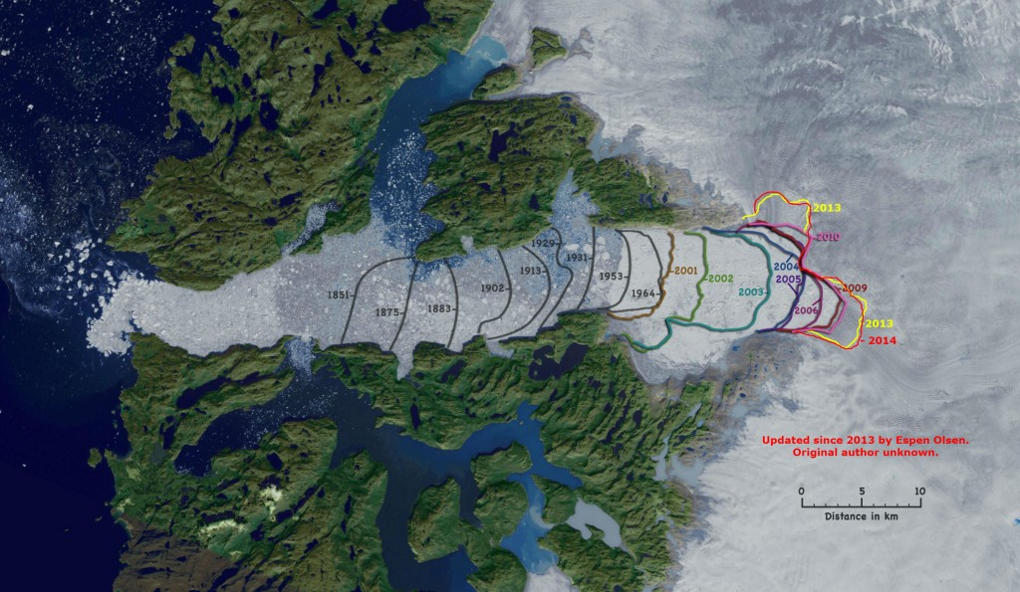

Fig. Jacobshavn glacier grounding zone in various years retreating inland at very high rate